**Consumer Credit analysis**

**Question a**

Discriminant Analysis (DFA) analysis is mainly performed on a set of data to identify the linear functions existing in the data. In this case, Canonical Discriminant Analysis (DFA) was performed on the dataset "Ass2Credit" to identify a linear function of the variables that best discriminates between individuals who pay off their debt (TARGET = 0) and those who do not (TARGET = 1).

**Table 1.0**

*Canonical Discriminant Analysis*

**The DISCRIM Procedure**

**Canonical Discriminant Analysis**

|  | **Canonical Correlation** | **Adjusted Canonical Correlation** | **Approximate Standard Error** | **Squared Canonical Correlation** | **Eigenvalues of Inv(E)*H = CanRsq/(1-CanRsq)** | | | | **Test of H0: The canonical correlations in the current row and all that follow are zero** | | | | |
| --- | --- | --- | --- | --- | --- | --- | --- | --- | --- | --- | --- | --- | --- |
|  | **Eigenvalue** | **Difference** | **Proportion** | **Cumulative** | **Likelihood Ratio** | **Approximate F Value** | **Num DF** | **Den DF** | **Pr > F** |
| **1** | 0.450851 | 0.436162 | 0.036790 | 0.203267 | 0.2551 |  | 1.0000 | 1.0000 | 0.79673341 | 13.04 | 9 | 460 | <.0001 |

1. Only one discriminant function was identified in the data. The Canonical DiscriminantAnalysis table above provides different statistics and also identifies the number of linear functions in the data.

The significant canonical correlation (0.450851) with a p-value <.0001 indicates that this single canonical discriminant function is significant. Thus, there is one significant discriminant function in this analysis. The below plot justifies the use of a single discriminant function in separating the two individual groups.

**Figure 1.0**

*Plot of Canonical Discriminant (Function) Analysis*

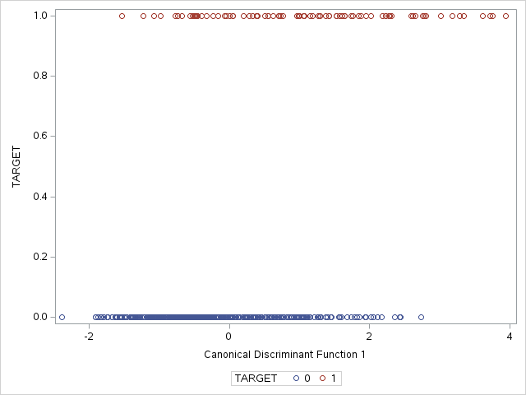

Above plot justifies the need to use a single discriminant function in separating the two individual groups. The clear separation along the x-axis shows that this function effectively discriminates between those who pay off their debt and those who do not.

1. Identifying the most important variables that discriminate between the different classes in the data, can be achieved by critically analyzing the "Total-Sample Standardized Canonical Coefficients" and "Pooled Within-Class Standardized Canonical Coefficients" tables from the output of the PROC DISCRIM procedure allowing to determine which variables contribute the most to the discrimination between classes. The variables with the highest absolute coefficient are deemed the most important.

**Table 2.0**

*Total-Sample Standardized Canonical Coefficients*

| **Total-Sample Standardized Canonical Coefficients** | | |
| --- | --- | --- |
| **Variable** | **Label** | **Can1** |
| **CollectCnt** | Number Collections | 0.0499636785 |
| **InqFinanceCnt24** | Number Finance Inquires 24 Months | 0.5466558736 |
| **InqTimeLast** | Time Since Last Inquiry | 0.1033763125 |
| **TLTimeFirst** | Time Since First Trade Line | -.1687640127 |
| **TLBalHCPct** | Percent Trade Line Balance to High Credit | 0.3080052121 |
| **TLSatPct** | Percent Satisfactory to Total Trade Lines | -.7163946321 |
| **TLSum** | Total Balance All Trade Lines | 0.0752990652 |
| **TLOpenPct** | Percent Trade Lines Open | 0.3295953728 |
| **TLDel60Cnt24** | Number Trade Lines 60 Days or Worse 24 Months | 0.3712633783 |

**Table 3.0**

*Pooled Within Canonical Structure Coefficients*

| **Pooled Within Canonical Structure** | | |
| --- | --- | --- |
| **Variable** | **Label** | **Can1** |
| **CollectCnt** | Number Collections | 0.172287 |
| **InqFinanceCnt24** | Number Finance Inquires 24 Months | 0.486341 |
| **InqTimeLast** | Time Since Last Inquiry | -0.083938 |
| **TLTimeFirst** | Time Since First Trade Line | -0.181288 |
| **TLBalHCPct** | Percent Trade Line Balance to High Credit | 0.401838 |
| **TLSatPct** | Percent Satisfactory to Total Trade Lines | -0.618060 |
| **TLSum** | Total Balance All Trade Lines | -0.029255 |
| **TLOpenPct** | Percent Trade Lines Open | -0.135203 |
| **TLDel60Cnt24** | Number Trade Lines 60 Days or Worse 24 Months | 0.599692 |

The most important variables from the data are TLSatPct, TLDel60Cnt24 and InqFinanceCnt24. These variables are the most critical in distinguishing between individuals who pay off their debt and those who do not.

**3**. I would consider reducing the variables in the data and focus on the most important variables as identified. Reducing the variables and focusing on the most important variables in the data will ensure the DFA methods sustains higher discriminative Power, Simplicity and increase classification accuracy.

**Question b**

1. **Fisher Discriminant Analysis**
2. Fisher Discriminant Analysis also know as Linear Discriminant Analysis (LDA) is a mathematical method used to classify data points based on their characteristics that separates the data distinctively. To classify the individuals, Fisher Discriminant Analysis method was applied. The method produced an overall classification accuracy of 68.40%. The method correctly classified 75.85% of class 0 and 67.44% of class 1 and had an error rate 28.36%.
3. **Table 4.0**
4. *Number of Observations and Percent Classified into TARGET*

| 1. **Number of Observations and Percent Classified into TARGET** | | | |
| --- | --- | --- | --- |
| **From TARGET** | **0** | **1** | **Total** |
| **0** | 314  75.85 | 100  24.15 | 414  100.00 |
| **1** | 28  32.56 | 58  67.44 | 86  100.00 |
| **Total** | 342  68.40 | 158  31.60 | 500  100.00 |
| **Priors** | 0.5 | 0.5 |  |

**Table 5.0**

*Error Count Estimates for TARGET*

| **Error Count Estimates for TARGET** | | | |
| --- | --- | --- | --- |
|  | **0** | **1** | **Total** |
| **Rate** | 0.2415 | 0.3256 | 0.2836 |
| **Priors** | 0.5000 | 0.5000 |  |

1. linear discriminant analysis is more preferable than the quadratic discriminant analysis method since the LDA results satisfies the assumption of equality of the covariance matrices of the two classes. The assumption of linearity holds for the data, this implies that the method finds a linear combination of the predictor variables that best separates the classes. Based on the visual inspection, the assumption of linearity is reasonable for the most important variables. In practical applications, especially in financial and consumer credit analysis, simpler models that are easy to explain to stakeholders are often preferred. The performance difference between the two methods is not substantial enough to warrant the additional complexity of QDA.

**References**

*Discriminant Function Analysis | SAS Data Analysis Examples*. (2018). <https://stats.oarc.ucla.edu/sas/dae/discriminant-function-analysis/>

*Fisher’s linear discriminant functions*. (2018, April 6). <https://communities.sas.com/t5/Statistical-Procedures/Fisher-s-linear-discriminant-functions/td-p/451752>